**National MI Puppet Documentation**



**AXIS Application Deployment Procedure:**

1. Login to Puppet Enterprise Console for a specific environment.

[*https://10.1.160.53/*](https://10.1.160.53/)

1. Login using your active directory logins to access the console.

*You will the see the following screen after login:*

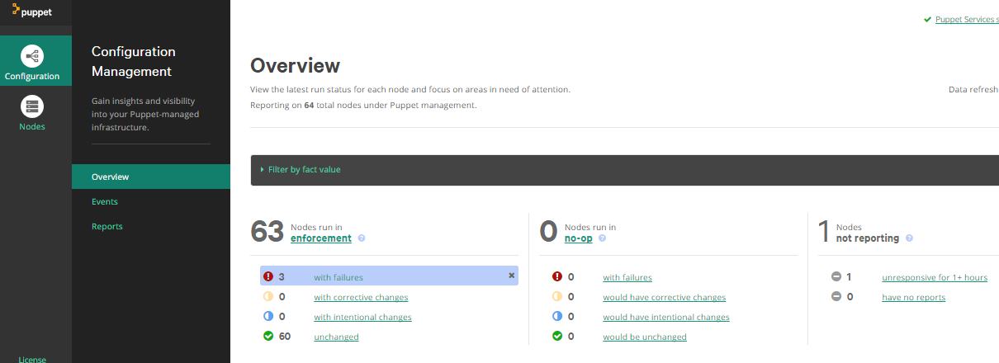

1. Navigate to the **Nodes 🡪 Classification** section and expand the environment you will be deploying to.

[*https://10.1.160.53/#/node_groups/groups*](https://10.1.160.53/#/node_groups/groups)

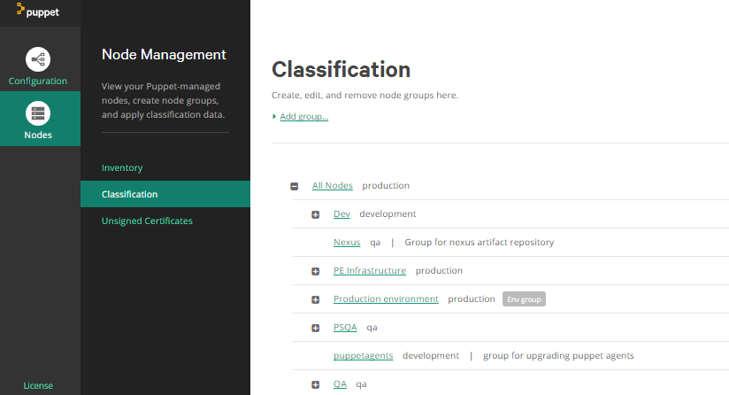

1. Let’s take for example we are deploying to QA, navigate to +**QA 🡪** +**Axis QA**

You can notice the QA <Application Name>.

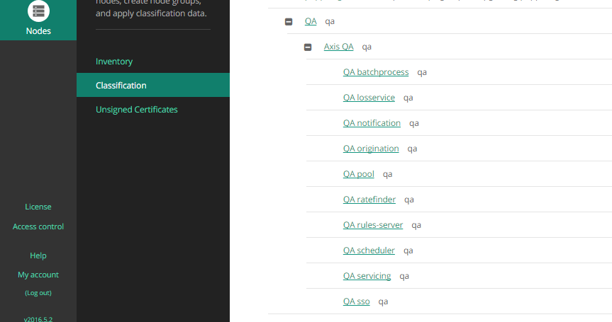

1. Click on each application you want to deploy and look for matching nodes first, and verify the nodes listed are the correct nodes belonging to the application.

**+Axis QA 🡪 QA batchprocess 🡪 Matching nodes**

1. Once confirmed, get into Classes and apply the following classes and parameters.

**+Axis QA 🡪 QA batchprocess 🡪 Classes**

***Classes will be empty for the first time:***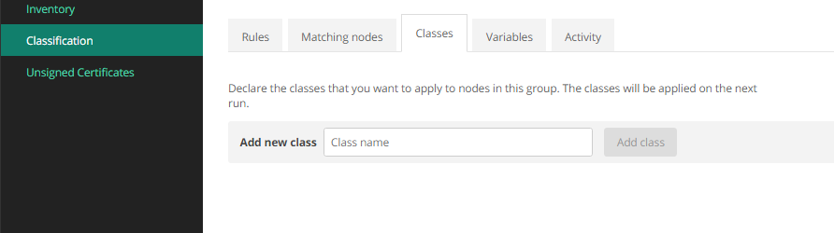

*Apply the following class (****profiles::axis::axis_app****) for the first time only.*

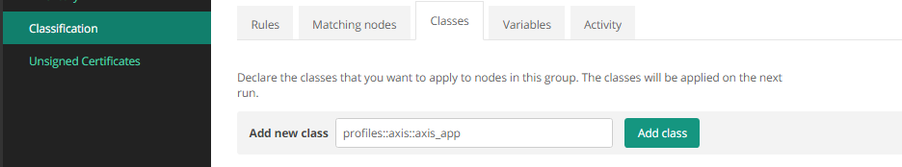

**Add the Class and add the following parameters.**

Select **parameter name** <parameter> and **Add parameter**.

*Add these 3 parameters:*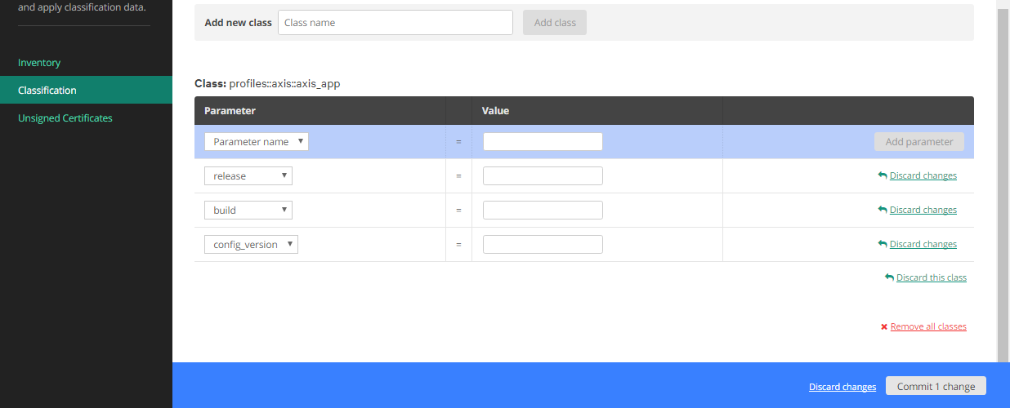

Now, apply the values to the parameters added.

* **Config_version** must be quoted Integer value, eg., 🡪 “707”
* **Build** is a 4 digit version, eg., 🡪 9.0.0.200
* **Release** is a string starting with Rel, eg., 🡪 Rel9 or Rel9.1

*Input those parameters:*

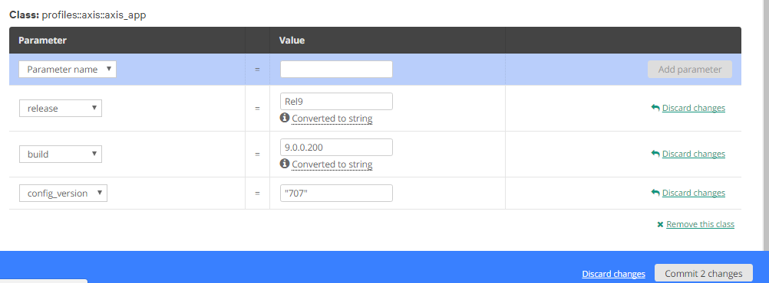

*Verify all those parameters and click* ***commit******changes*** *to deploy.*



1. If the class is already applied, then just edit the parameters.

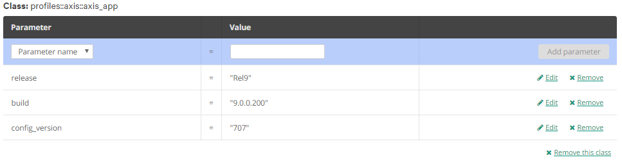

*Verify all those parameters and click* ***commit******changes*** *to deploy.*



1. Continue the same steps (4, 5, 6, and 7) for all other applications except **QA Notification**.

**Classification 🡪 QA <Application name>**

**NOTE:**

We can deploy one or more specific applications also. For example, we are planning to do a new axis deployment on Origination. So, we can only update the parameters for QA Origination and apply the changes.

By implementing this, we can achieve the *Application-Specific Deployments*.

**Notification Server**

1. For notification server, the class is different from all other applications.

**Classification 🡪 +QA 🡪 +Axis QA 🡪 QA notification**

Verify Matching node, then Click classes and add the following class (instead of axis_app) for the first time only. Add new class: **profiles::axis::axis_notification 🡪 Add class**

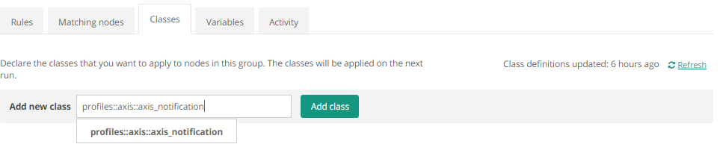

Now, apply the values to the parameters added.

* **Config_version** must be quoted Integer value, eg., 🡪 “707”
* **Build** is a 4 digit version, eg., 🡪 9.0.0.200
* **Release** is a string starting with Rel, eg., 🡪 Rel9 or Rel9.1

*Input those parameters:*

*Verify all those parameters and click* ***commit******changes*** *to deploy.*

1. If the class is already applied, then just edit the parameters.

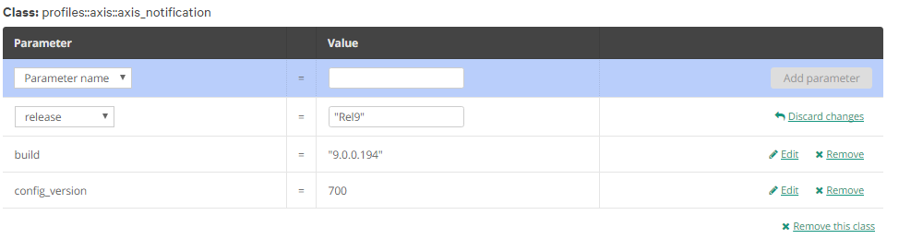*Verify all those parameters and click* ***commit******changes*** *to deploy.*



**Events and Reports:**

1. Once all the valueppameters s.sss is differenct from all other applications. ted are the correct nodes belonging to applications are updated, look for changes in the console in Configuration tab.

[**https://docs.puppet.com/pe/2016.5/CM_overview.html**](https://docs.puppet.com/pe/2016.5/CM_overview.html)

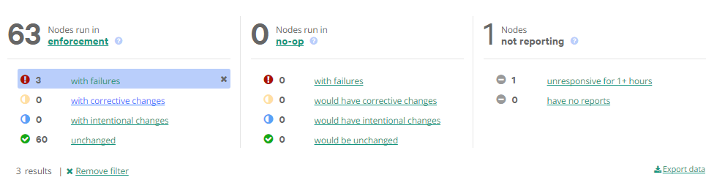

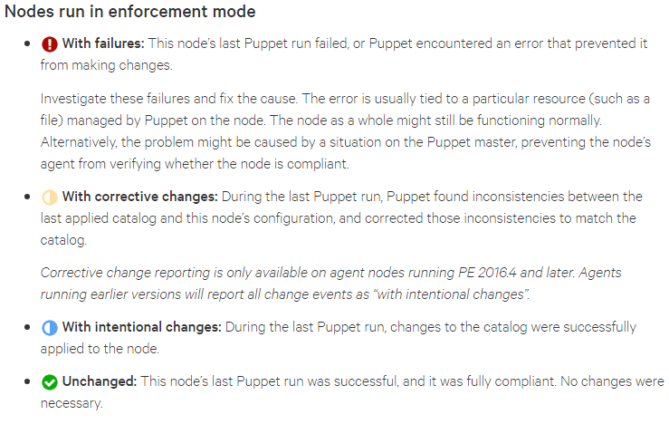

For viewing reports and events, walk through the following documentation in puppet docs.

[**https://docs.puppet.com/pe/2016.5/CM_events.html**](https://docs.puppet.com/pe/2016.5/CM_events.html)

You can also look into event changes with respect to state (failed, changes, unchanged)

**Configuration 🡪 Events 🡪 State (Failure, Corrective, Intentional Changes)**

For viewing reports:

[**https://docs.puppet.com/pe/2016.5/CM_reports.html**](https://docs.puppet.com/pe/2016.5/CM_reports.html)

**To ensure puppet won’t start the tomcat while DB patches are applied:**

This can be achieved by not managing QA Nodes to apply *axis* class. Follow these steps to do so:

**Classification 🡪 QA 🡪 Rules**

* Add a parameter as mentioned:
  + Fact 🡪 **nmi_environment**
  + Operator 🡪 **!=**
  + Value 🡪 **qa**

**Add rule.**

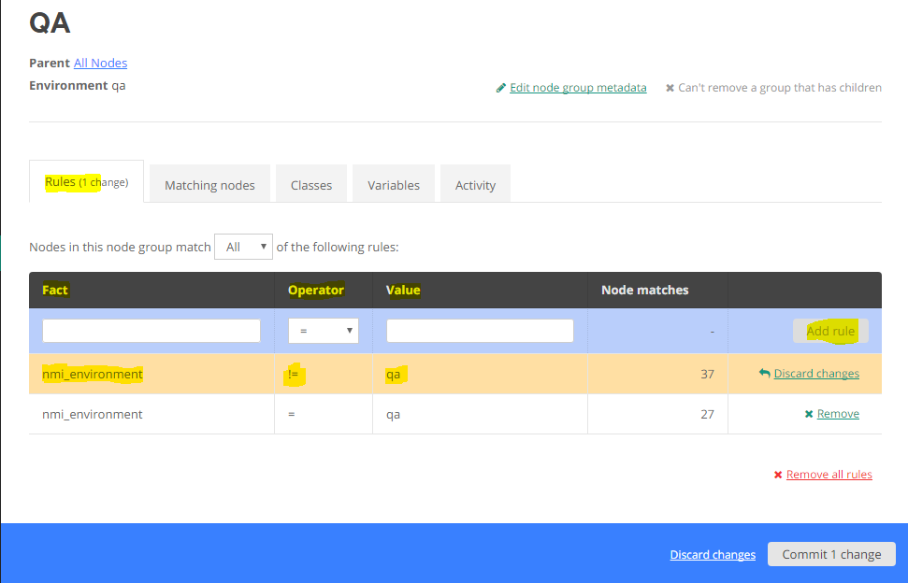

* Before commit, get into **Matching nodes** and you should notice **0 nodes**.
* Commit Changes.
* Now, you can continue with DB patches.
* Once the Db patches are completed.

**Classification 🡪 QA 🡪 Rules 🡪 Remove the Parameter just added 🡪 Commit.**

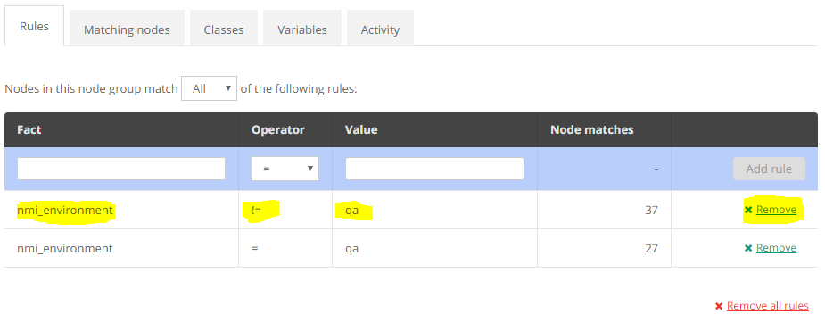

**Look for Matching Nodes 🡪 Commit Changes.**

**To ensure puppet won’t start the tomcat and to apply the axis class on specific application:**

Instead of disabling puppet and not to manage the axis class on all nodes in particular environment, we can also disable to a specific application also.

**Classification 🡪 +QA 🡪+Axis QA 🡪 QA <Application>**

**Under rules:**

Fact 🡪 **nmi_role**

Operator 🡪 **!=**

Value 🡪 **Application-name**

**Add rule, then**

**Look for 0 Matching Nodes.**

**Commit Changes.**

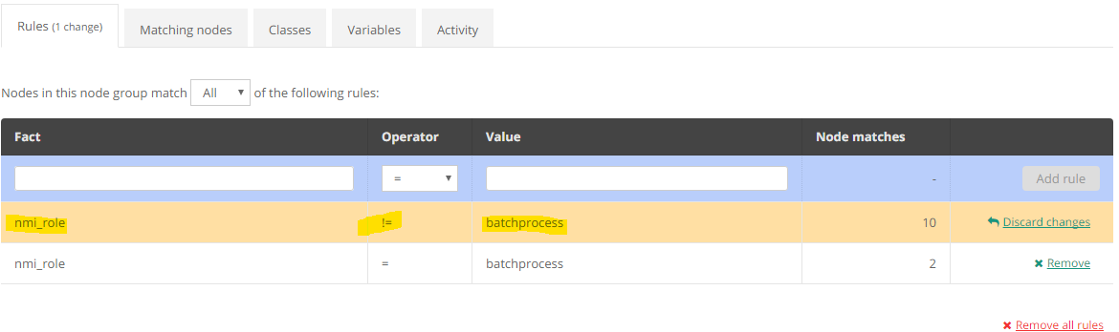

To enable Puppet again, follow the reverse process.

Remove the rule applied before and commit changes.

**Remove 🡪 nmi_role != batchprocess**

**Commit Changes**

**To apply forceful changes without waiting for the puppet agent for another 15min.**

**Node name 🡪 Run Puppet 🡪 Run**

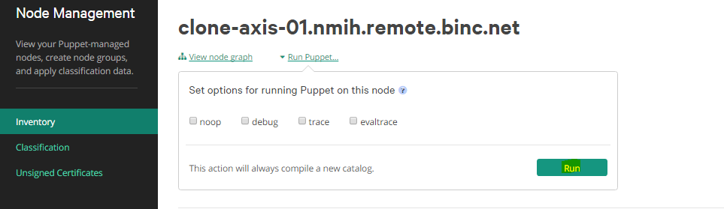

**Puppet/Axis Troubleshooting**

**AXIS-PUPPET:**

**Things to remember:**

* Make sure to update the right version, build and release parameter, failing to do so would result in deploying the wrong version of deployment.
* Puppet agent will run for every 15min randomly on each server. So, wait until the next report generated to see the events (failure, changes).
* Make sure SVN has the right config version and right builds on artifact server (*D*Nexus).
* Make sure the matching nodes in the classification belongs to respective application.
* Make sure puppet service on nodes is stopped, as puppet agent run is schedule in cron job.
* Make sure only one tomcat is running during the Axis deployments.

**Troubleshooting:**

* To disable the puppet on specific application or environment, please refer to Doc: *Above.*
* If nodes are unresponsive,
  + They might be disabled or an old puppet instance is running in background.
  + If any old instance running, just kill the older instance and run puppet again.
* Errors like Connection refused may come, if the nodes are not able to access the puppet master.
  + Look into the nodes and make sure all the required ports are opened.

**SVN-CONFIG’S:**

**Troubleshooting:**

* *If Puppet failed to deploy the Axis-config’s during the Axis deployments?*
  + Go the application config directory (/opt/axis/<app-name>/conf)
  + In /opt/axis/<app-name>/conf/common/ - execute these commands.
    - ***#svn info*** – Check the latest Revision# matches the config_version specified in Puppet parameters.
  + If the config’s are still not updated, do this:
    - Remove the /opt/axis/<app-name>/conf directory
    - #***puppet agent –t*** 🡪 look for the changes/config’s updated during the puppet agent run or wait for next puppet run (15min).
  + To check out the Latest version of the svn config’s
    - cd /opt/axis/<app-name>/conf/<common> or <app-name>
    - **#*svn update 🡪*** Checkout’s the latest version that’s in svn server.
    - ***#svn info 🡪*** Checkout for the latest revision no.
  + In case to download the svn config’s manually, do this:
    - *cd /opt/axis/<app-name>/conf/common*
    - ***#svn --non-interactive switch -r <CONFIG_VERSION> <URL> --force --accept mine-full***

***(or)***

* + - ***#svn co –r <CONFIG_VERSION> <URL>***
      * CONFIG_VERSION 🡪 Puppet Config version
      * SVN URL 🡪 URL that’s in output of #*svn info*
* **SVN URL**:
  + DEV/QA/PSQA 🡪 *svn://10.1.160.31:3690/branches/<Rel #>/<branch>/common*

*🡪 svn://10.1.160.31.3690/branches/<Rel #>/<branch>/<app-name>*

* + STG/PSS/CI 🡪 *svn://10.20.89.10:3690/branches/<Rel #>/<branch>/common*

*🡪 svn://10.20.89.10:3690/branches/<Rel #>/<branch>/<app-name>*

* + PROD 🡪 *svn://10.1.92.121:3690/branches/<Rel #>/<branch>/common*

*🡪 svn://10.1.92.121:3690/branches/<Rel #>/<branch>/<app-name>*

**ARTIFACTS-NEXUS:**

**Troubleshooting:**

* *If Puppet failed to deploy the artifacts (war’s) during the Axis deployments?*
  + Remove the old war and run puppet agent –t
  + Still the war’s not updating? Download manually, do this:
    - *Go the nexus url in browser,* [*https://nexus-ip:8081/nexus/*](https://nexus-ip:8081/nexus/)
    - Nexus login 🡪 No need user/account 🡪 Anonymous access enabled.
    - *Repositories 🡪 Releases 🡪 Browse Storage 🡪 Releases 🡪 com 🡪 nmi 🡪 axis 🡪 <app-name> 🡪 build# 🡪 <app-name-build#>.war*
    - *Click on it, In right section 🡪 Artifact 🡪 Look for Repository Path:*
    - *Right click on Repository Path and copy the link address.*
    - *Use this copied url for the war to download.*
    - *Login the App server to download*
    - cd /usr/share/apache-tomcat/webapps/
    - remove the old-war and <app-directory>
    - ***wget <Repository-path copied> 🡪*** *you can use* ***curl*** *if wget doesn’t work.*

***http://<nexus-ip>:8081/nexus/service/local/repositories/ releases/content/com/nmi/axis/ <app-name>/<build#>***

***/<app-name-build#>.war***

* + - rename the war from *<app-name-build#>.war to <app-name>.war*
    - *Restart the tomcat, if needed.*
  + You can download the war’s to a local machine and scp/winscp over to the <app-server> if either wget/curl doesn’t work.
* *Sample nexus-path copied:*

[***http://10.1.160.133:8081/nexus/service/local/repositories/releases/content/com/nmi/axis/batchprocess/10.0.0.100/batchprocess-10.0.0.100.war***](http://10.1.160.133:8081/nexus/service/local/repositories/releases/content/com/nmi/axis/batchprocess/10.0.0.100/batchprocess-10.0.0.100.war)

* **NEXUS-URL**:
  + DEV/QA/PSQA 🡪 <http://10.1.160.133:8081/nexus/>
  + STG/PSS/CI 🡪 <http://10.10.92.133:8081/nexus/>
  + PROD 🡪 <http://10.1.92.129:8081/nexus/>

**Things to report to DevOps Team:**

* If any axis application server in an unresponsive state.
* If the matching nodes not listed for a specific application.
* If Puppet enterprise console is not accessible.
* If nodes are unable to apply the latest deployment.
* If any errors while applying the axis, might be because of network, ACL, firewall and etc.,
* If any new servers need to be added.
* If SVN config is not able to update, might be because of SVN_MIRROR.
* If war are not able to update, might be because of Nexus
* If any file permission changes needed.

**JIRA:**

Create a ticket for any other puppet error, failure, and other requests.

While creating a ticket for Puppet, include the following components and assign it to the right group.

Application: **Puppet**

Component: **Task: Server- Linux**

Assignee: **Puppet group** (*Larry Ramos*)